Unit exam

Unit 1 Chemical fundamentals: structure, properties and reactions

Name:

Class:

Time permitted: 70 minutes

|  |  |  |  |  |
| --- | --- | --- | --- | --- |
|  | Section | Number of questions | Marks available | Marks achieved |
| A | Multiple choice | 30 | 30 |  |
| B | Short answer | 10 | 40 |  |
|  | Total |  | 70 |  |

Grade:

Comments:

Section A Multiple choice (30 marks)

Section A consists of 30 questions, each worth one mark. Each question has only one correct answer. Circle the correct answer. Attempt all questions. Marks will not be deducted for incorrect answers. You are advised to spend no more than 30 minutes on this section.

1 The smallest particle of an element is:

A an atom.

B a molecule.

C a formula unit.

D a compound.

2 The subatomic particle that contributes most of the mass to an atom is:

A nucleus.

B proton.

C electron.

D neutron.

3 The number of electrons of an element on the periodic table is equal to:

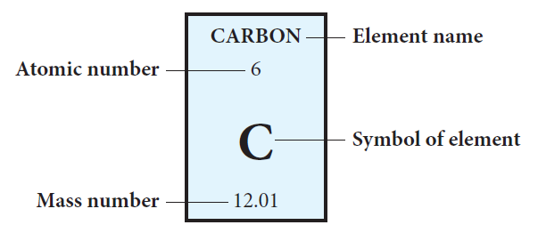

A the atomic mass.

B the atomic number.

C atomic number minus atomic mass.

D atomic mass minus atomic number.

4 The relative molecular mass of oxygen difluoride is:

A 16.

B 35.

C 54.

D 49.

5 The element phosphorus is located on the periodic table in:

A row 2, column 5.

B row 2, column 15.

C period 3, group 15.

D period 3, group 5.

6 The electron configuration of calcium is:

A 2,8,2,8.

B 8,8,4.

C 2,8,10.

D 2,8,8,2.

7 Which of the following has the smallest atomic radius?

A Sulfur

B Selenium

C Barium

D Calcium

8 The concentration of copper in a sample with an absorbance of 0.8 is closest to:

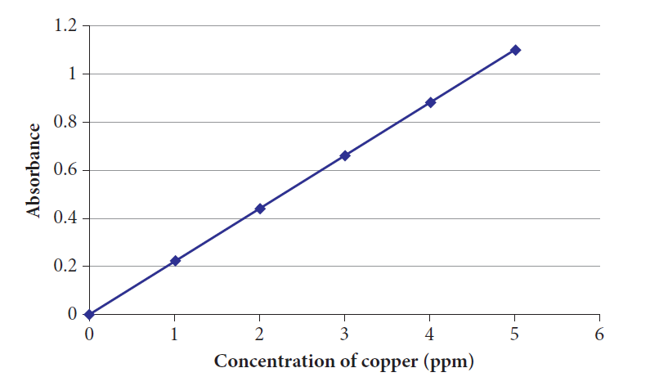

A 0.15 ppm.

B 3 ppm.

C 3.5 ppm.

D 0.2 ppm.

9 Which of the following is an example of a physical change?

A A gas being produced when a metal is added to an acid

B Salt crystals dissolving in water

C A solid forming when two solutions are added together

D A temperature increase when a metal is added to water

10 Which of the following substances could be separated using a separating funnel?

A Water and ethanol

B Oil and vinegar

C Sandy water

D Water and sugar

11 Which of the following separation techniques is based on a difference in particle size?

A Sieving

B Vaporisation

C Fractional distillation

D Magnetic separation

12 Which of the following pieces of apparatus is not used in distillation?

A Round-bottomed flask

B Condenser

C Evaporating basin

D Thermometer

13 Which of the following techniques does not keep all substances in the mixture?

A Magnetic separation of iron filings and sulfur powder

B Filtration of sandy water

C Distillation of salty water

D Evaporation of salty water

14 Which of the following is an isotope of carbon 12?

A Diamond

B Graphite

C Radioactive carbon-14

D Fullerenes

15 The diagram below is an example of which type of substance?

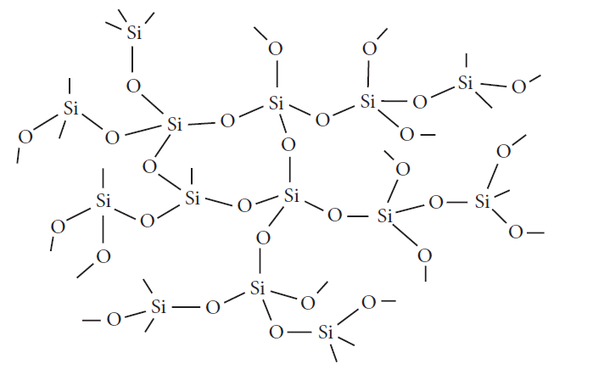

A Covalent network

B Covalent molecular

C Ionic

D Metallic

16 Which of the following is a property of ionic substances only?

A Conducts electricity in the aqueous state

B High melting point

C Hard and brittle

D Generally insoluble in water

17 Which of the following is the formula for butane?

A C4H10

B C4H8

C C4H6

D C4H4

18 The following diagram demonstrates which property of metals?

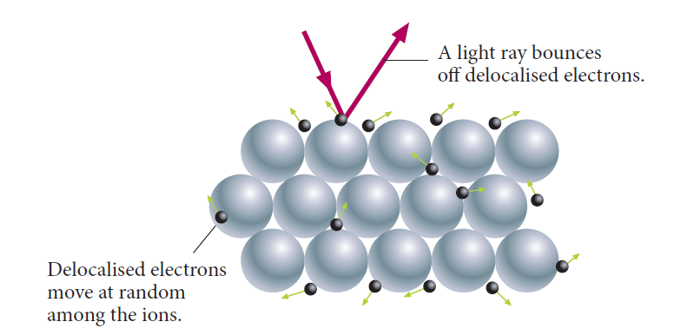

A Ductility

B Electrical conductivity

C Heat conductivity

D Lustre

19 Which of the following polyatomic ions has a valency of –2?

A Ammonium

B Carbonate

C Hydroxide

D Phosphate

20 Which substance is most likely to be malleable and conduct electricity when solid?

A Covalent network

B Covalent molecular

C Metallic

D Ionic

21 Which two substances have the same number of valence electrons?

A Beryllium ion and helium atom

B Beryllium ion and carbon atom

C Beryllium ion and magnesium atom

D Beryllium ion and neon atom

22 What is the name of the compound N2O3?

A Nitrogen trioxide

B Nitrogen oxide

C Nitric oxide

D Dinitrogen trioxide

23 Which of the following elements is least likely to be involved in chemical reactions?

A Cu

B Ne

C Ag

D Pb

24 A molecule is described as:

A the smallest particle of an element.

B two metallic atoms held together by electrostatic attraction.

C being made up of two or more atoms connected by covalent bonds.

D being made up of a metal and a non-metal atom.

25 Consider three metals, L, M and N. L reacts with cold water; M does not react with cold water or dilute acid; N reacts with dilute acid but not with water. The order of these metals in decreasing reactivity is:

A L, M, N

B M, N, L

C N, M, L

D L, N, M

26 Which of the following is not a correct general equation for a spontaneous reaction?

A Acid + metal → salt + water

B Metal + acid → salt + hydrogen

C Metal + oxygen → metal oxide

D Metal + water → salt + hydrogen

For questions 27 and 28 refer to the following chemical equation:

Solid copper(II) carbonate + heat 🡪 solid copper(II) oxide + carbon dioxide gas.

27 Which is the correct chemical formula for copper(II) oxide?

A 2CuO

B CuO2

C Cu2O

D CuO

28 The chemical reaction is an example of:

A a combustion reaction.

B an addition reaction.

C a substitution reaction.

D a decomposition reaction.

29 Which of the following is correct?

A Energy is not conserved as heat energy is added to the reaction.

B The reactants contain more chemical energy than the products.

C The reaction is endothermic.

D The reaction is exothermic.

30 12 K is equal to:

A absolute zero.

B 12°C.

C 285°C.

D –261°C.

Section B Short answer (40 marks)

Section B consists of 10 questions. Write your answers in the spaces provided. You are advised to spend 40 minutes on this section.

1 a Describe the structure of the atom. (1 mark)

b Draw particle diagrams to explain the difference between a diatomic element and a compound. Use hydrogen gas and water as your examples. (2 marks)

c Draw an electron configuration diagram for the magnesium ion. (1 mark)

2 a Describe the difference between an isotope and an allotrope using specific examples. (2 marks)

b Explain the differences in the electronegativity and metallic character of caesium and chlorine. (2 marks)

3 a Use examples to explain the differences between heterogeneous and homogeneous mixtures. (2 marks)

b 2.5 g of a white powder was in a crucible. It was heated with a Bunsen burner until a liquid was formed. After cooling a piece of white solid remained. It weighed 2.0 g. Assess whether this is a physical or chemical change. (2 marks)

4 a A vacuum cleaner uses the process of filtration to separate dust particles from air. Choose another everyday example where a separation technique is used and explain how it separates the components of the mixture. (2 marks)

b Draw a scientific diagram of the apparatus you would use to separate the components of a solution of salty water when you only need to keep the solute. (2 marks)

5 Compare at least two properties of covalent network and covalent molecular substances in terms of structure and/or bonding. (4 marks)

6 a Describe two ways in which fluorine can achieve a full outer shell of electrons, using examples. (2 marks)

b Contrast substitution and addition reactions of hydrocarbons, using examples. (2 marks)

For questions 7 and 8 refer to the solubility rules below.

|  |  |
| --- | --- |
| Soluble anions | Exceptions |
| NO3– | None |
| CH3COO– | Ag+ slightly soluble |
| Cl– | Ag+ insoluble, Pb2+ slightly soluble |
| Br– | Ag+ insoluble, Pb2+ slightly soluble |
| I– | Ag+, Pb2+ insoluble |
| SO4– | Ba2+, Pb2+, Sr2+ insoluble, Ag+, Ca2+ slightly soluble |
| Insoluble anions | Exceptions |
| OH– | Group 1, NH4+, Ba2+, Sr2+ soluble; Ca2+ slightly soluble |
| O2– | Group 1, NH4+, Ba2+, Sr2+, Ca2+ soluble |
| S2– | Groups 1 and 2, NH4+ soluble |
| CO32– | Group 1, NH4+ soluble |
| SO32– | Group 1, NH4+ soluble |

7 a Write a balanced chemical equation, including states, for the reaction between solutions of iron(III) sulfate and barium hydroxide. (2 marks)

b Write a net ionic equation for the above reaction. (1 mark)

c Calculate the number of moles in 0.98 g of barium hydroxide. (1 mark)

8 a Calculate the number of moles of iron(III) sulfate required to fully react with 0.98 g of barium hydroxide. (1 mark)

b Calculate the mass of iron(III) hydroxide produced in the reaction.  
(2 marks)

c Calculate the number of particles of iron(III) hydroxide produced in the reaction. (1 mark)

9 1.75 g of ethanol (C2H6O) is placed in a spirit burner and burned to heat up 200 g of water in a beaker. The temperature of the water increases by 55°C. The specific heat capacity of ethanol is 4.184 J K–1g–1.

a Calculate the moles of ethanol used. (1 mark)

b Calculate the energy required to change the temperature of the water by 55°C. (1 mark)

c Calculate the heat of combustion of ethanol (heat produced per mole of ethanol). (2 marks)

10 In question 9, 1.75 g of ethanol reacted with oxygen to undergo combustion.

a Write a balanced chemical equation for the complete combustion of ethanol. (1 mark)

b Draw an enthalpy diagram to help explain whether the reaction is endothermic or exothermic. (3 marks)